Дата: 24.01.2025

Клас: 7-Б

Предмет: англійська мова

Тема: Похід до кінотеатру. Граматика types of comparison.

Мета: : формувати навички вживання лексичних одиниць по темі; удосконалювати навички читання, аудіювання й усного монологічного мовлення; розвивати пізнавальні інтереси учнів; виховувати інтерес до самостійного пошуку потрібної інформації, а також загальну культуру учнів.

Вчитель: Руда Д.В.

Хід уроку

1.Greeting

Good afternoon, guys! I’m tickled pink to see you. Are you ready to start our lesson? All set?

Let`s get down to business.

2. Wаrm up / Listening

Уважно слухати аудіо трек і дати відповідь на питання вчителя <https://www.youtube.com/watch?v=4duiOE2Beno> .

3. Speaking

Дати усно відповіді на питання :

Do you think action movies are bad for children?

Which do you prefer, to watch movies or to read books?

How much money do you spend when you go to movies?

What do you prefer, animated movies or real movies?

What is your favorite movie soundtrack?

Do you think historical movies are educational?

Do you like documentaries?

Who is your favorite movie hero?

What do you think about comic books movies?

Can you remember the name of the first movie you saw that made you cry?

What is your favorite classical movie?

Which do you prefer, comedy movies or horror movies?

Have you ever watched a movie twice that you disliked?

Do you ever download bootleg movies?

In your country what common courtesies apply when watching a movie at the cinema?

Have you ever seen a movie in another country? Describe the experience.

What movie ratings are enforced in your country?

What does it mean if a movie "bombs"?

Are movie trailers common at the cinema in your country?

Do you like foreign films that are dubbed in your mother tongue or do you like watching the film in its original form?

What kind of movie would you like to star in? Why?

Do you think there should be more movies made in your country?

What is something that you have never seen happen in a movie?

What things happen too often in movies?

What is the name of a boring movie you have seen. Is there a way to make it better?

How would you make a really bad movie?

Which movie star do you think should die today?

Which movie star should live forever?

4. Повторення

Словник :

*Storyline-сюжетна лінія (сторілайн)*

*Realistic-реалістичний(ріалістік)*

*Impressed-Вражений(імпресд)*

*To find out-дізнатися(файнд аут)*

*Include-включати(інклюд)*

*Shortly-невдовзі, незабаром (шотлі)*

*To sum up- підсумовуючи …(ту сам ап)*

5. Writing

Виконати письмово вправу на граматику.

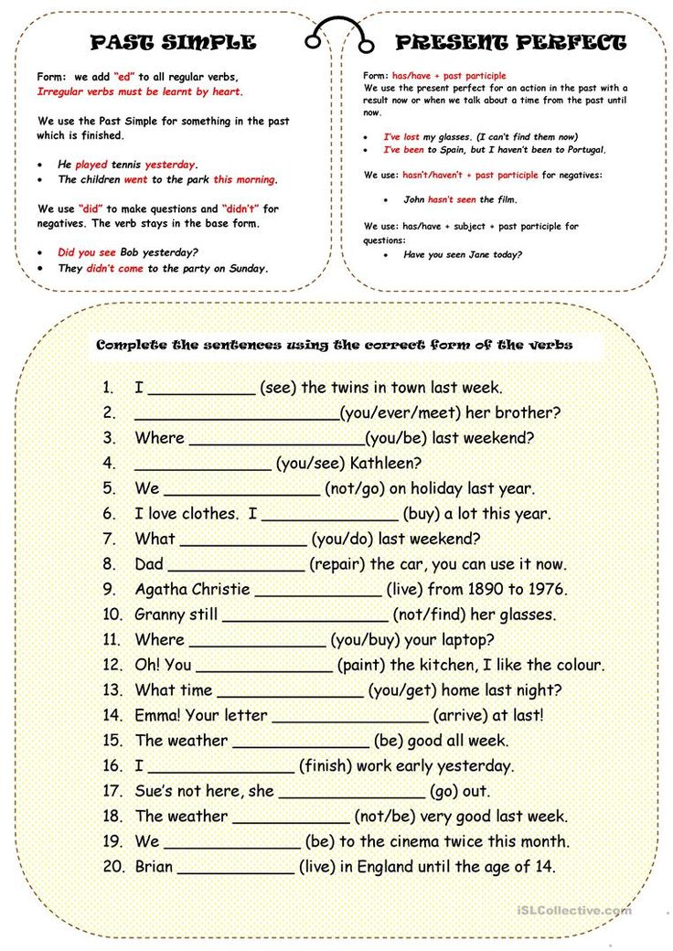

6. Vocabulary

To invent-инаходити (інвент)

To director-режисувати(дайректа)

Impressed-вражений(імпрест)

Hidden-схований(хіден)

Well known-відомий(вел наун)

7. Homework

1. Виконати вправу подану нижче.

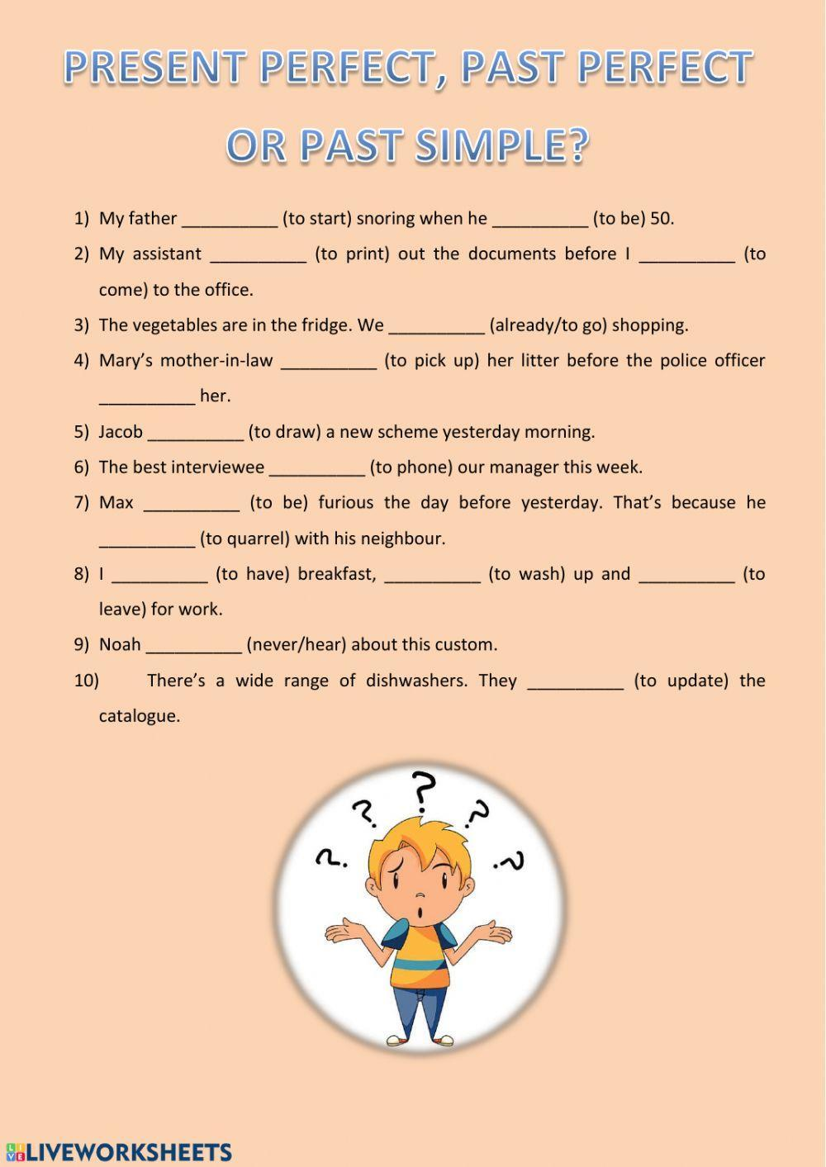

2. Вивчити слова з конспекту.